A171-ME-Egypt-Woman on Camel

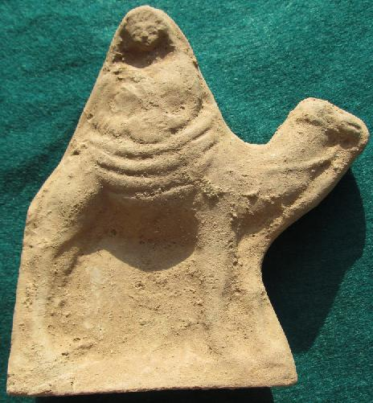

Fig. 1. Egypt-Woman on Camel-Hellenistic Terracotta-3rd-2nd century BCE

Case no.: 2

Accession Number: A171

Formal Label: ME-Egypt-Woman on Camel-Hellenistic Terracotta-3rd-2nd century BCE

**Display Description:** This Hellenistic, 3rd-2nd century BCE, terracotta from Alexandria, Egypt, portrays a half-body female statuette wearing a tunic covered by a himation gown and secured on camelback by a heavily folded tapestry. She is portrayed as holding, with both hands, a tambourine, a musical instrument that was played by women accompanying ceremonial processions, especially in military triumphs in the pre-Islamic Middle East.

**LC Classification:**

Date or Time Horizon: 3rd-2nd century BCE

Geographical Area: Alexandria, Egypt

**Map, GPS coordinates: 31.31298 30.05882**



Fig. 2. Map of Alexandria in Egypt.

Cultural Affiliation: Hellenistic

Medium: Terracotta

Dimensions: 16 cm. x 13 cm.

Weight:

Condition: Original

Provenance: Alexandria.

**Discussion:**

The seated figure is performing a ritual musical rite honoring her military audience. It should also be noted that "A rider on a camel is an iconographical convention representing Arabia or the Nabatean kingdom" (Patrich 1990:73, n. 53), and we may add the iconographic convention diffused w to Egypt and n to Syria as well.

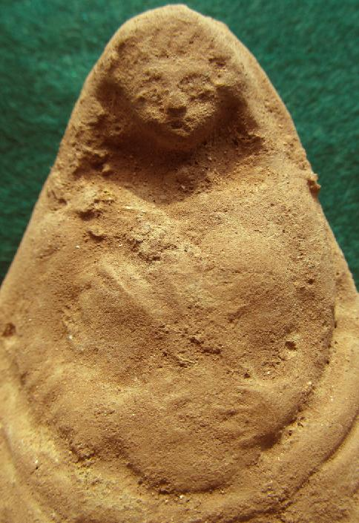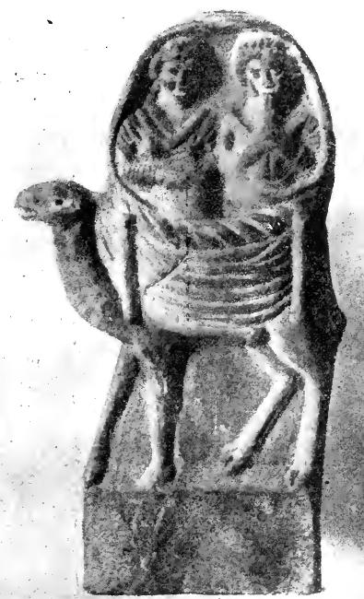

Fig. 3. Detail of figure 1 above. Fig. 4. This Hellenistic, 3rd-2nd century BCE, terracotta from Damascus, Syria, portrays two half-body female statuettes with the right female holding a flute and the left female holding a tambourine. They are wearing pleated gowns, with bouffant hair dos and are secured on camelback by a heavily folded tapestry. After Cumont 1917: 273, Fig. 94. (Musée du Louvre)



Fig. 5. This Hellenistic, 3rd-2nd century BCE, terracotta from Alexandria, Egypt portrays two half-body female statuettes holding, with both hands, tambourines and wearing pleated gowns, with bouffant hair dos. They are secured on camelback by a heavily folded tapestry. From https://foursquare.com/v/ny-carlsberg-glyptotek/4adcdafdf964a520ea5d21e3/photos

**References:**

Cumont, Franz. 1917.[*Études Syriennes*](http://www.worldcat.org/title/etudes-syriennes-par-franz-cumont/oclc/459002401&referer=brief_results). Paris: A. Picard.

Patrich, Joseph. 1990. [*The formation of Nabatean art: prohibition of a graven image among the Nabateans*](http://www.worldcat.org/title/formation-of-nabatean-art-prohibition-of-a-graven-image-among-the-nabateans/oclc/21442144&referer=brief_results)*.* Jerusalem: Magnes Press, Hebrew University; Leiden; New York: E.J. Brill.